Enterprise Knowledge graph with LLM
(13 size) A Project Based Learning Report Submitted in partial fulfilment of the requirements for the award of the degree

of

Bachelor of Technology
in The Department of Computer Science & Engineering
BIG DATA ANALYTICS – 23DSB3303A

Submitted by
2310030028 – Karthik Mateti
2310030412 – N. Aravind
23100030193 – B. Karthik Reddy
2310030121 – K. RaviKiran

Under the guidance of
Dr. T. Aruna Sri



Department of Electronics and Communication Engineering
Koneru Lakshmaiah Education Foundation, Aziz Nagar
Aziz Nagar – 500075
FEB - 2025.

Abstract

Modern enterprises generate vast volumes of structured and unstructured data from diverse sources, making it challenging to extract meaningful insights using traditional data management approaches. These conventional systems often fail to capture the relationships, context, and semantic meaning embedded within organizational data. To address this limitation, this project proposes the design and implementation of an Enterprise Knowledge Graph integrated with Large Language Models (LLMs).
The enterprise knowledge graph models data as interconnected entities and relationships, enabling enhanced contextual understanding, improved data discoverability, and advanced reasoning capabilities. By integrating LLMs, such as advanced generative AI models, the system leverages natural language processing to automatically extract entities and relationships from textual data, enrich the knowledge graph, and enable semantic search and conversational querying.
This integration facilitates intuitive access to enterprise knowledge through natural language interfaces, allowing users to obtain accurate, context-aware insights efficiently. The proposed system enhances knowledge management, reduces data silos, and supports intelligent decision-making across various domains, including customer support, document analysis, compliance, and strategic planning.
Overall, the project demonstrates how combining knowledge graphs with LLMs can transform raw organizational data into actionable knowledge, resulting in a scalable, adaptive, and human-centric enterprise solution for modern data-driven environments.

List of Figures

Figure No. | Figure Title
Figure 1 | Overall System Architecture of Enterprise Knowledge Graph with LLMs
Figure 2 | Data Flow between User, LLM, Vector DB, and Graph DB
Figure 3 | Hybrid Memory Architecture (Vector + Graph Integration)
Figure 4 | Query Processing Pipeline
Figure 5 | Methodology Workflow Diagram
Figure 6 | Embedding Generation and Storage in Vector Database
Figure 7 | Knowledge Graph Representation using Neo4j
Figure 8 | Results - Execution
Figure 9 | Results – Execution
Figure 10 | Result - Execution
Figure 11 | Result – Sample Output
Figure 12 | Architecture of Enterprise Knowledge Graph with LLM Integration

Table of Contents

Section No. | Title
1 | Introduction
2 | Methodology
2.1 | Selecting a Template
3 | Experiments
4 | Results
5 | Conclusion and Future Work
6 | References

Enterprise Knowledge graph with LLM

Introduction
In recent years, the rapid advancement of artificial intelligence, particularly large language models (LLMs), has significantly transformed the way organizations process and utilize information. LLMs such as GPT-based models are capable of understanding natural language, generating human-like responses, and performing complex reasoning tasks. However, despite their impressive capabilities, traditional LLMs are inherently stateless, meaning they do not retain memory of previous interactions unless explicitly provided within the prompt. This limitation reduces their effectiveness in enterprise environments where contextual continuity, historical knowledge, and structured information are critical.
Enterprises typically deal with vast amounts of structured and unstructured data spread across multiple systems, including databases, documents, and applications. Managing this data efficiently and extracting meaningful insights from it remains a major challenge. Knowledge graphs have emerged as a powerful solution to address this problem by representing information in a structured format using entities and relationships. A knowledge graph enables better data integration, semantic understanding, and relationship-based querying, making it highly suitable for enterprise knowledge management.
The integration of knowledge graphs with LLMs presents a promising approach to overcome the limitations of standalone models. By combining the reasoning capabilities of LLMs with the structured representation of knowledge graphs, it becomes possible to create intelligent systems that can both understand context and maintain long-term memory. Additionally, vector databases play a crucial role in this integration by enabling semantic similarity search through embeddings, allowing the system to retrieve relevant past information based on meaning rather than exact keywords.
This project focuses on designing and implementing an Enterprise Knowledge Graph system enhanced with LLMs. The system introduces a hybrid memory architecture that combines vector-based storage and graph-based storage. The vector database stores embeddings of user interactions for efficient similarity search, while the graph database captures relationships between entities, enabling structured reasoning. This dual approach allows the system to provide more accurate, context-aware, and meaningful responses.
The proposed system aims to simulate an enterprise-level intelligent assistant capable of remembering past interactions, understanding user intent, and leveraging stored knowledge effectively. It also incorporates a fallback mechanism to ensure system reliability in cases where certain components, such as the graph database, are unavailable. By addressing the limitations of stateless LLMs and enhancing them with persistent memory, this work contributes to the development of next-generation AI systems for enterprise applications such as customer support, knowledge management, and decision-making systems.

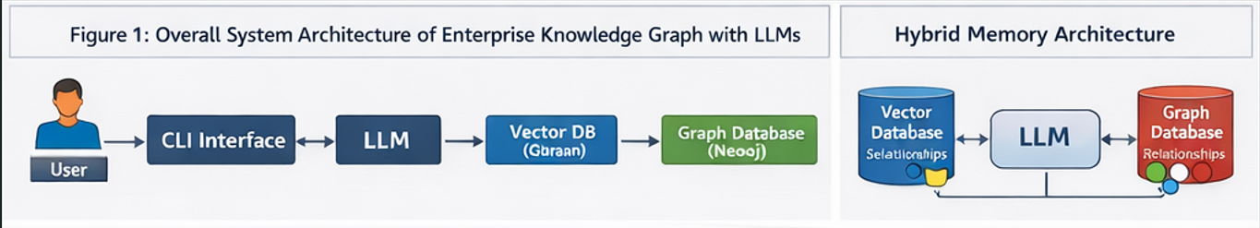
Figure 1

Methodology
The proposed system follows a hybrid architecture that integrates large language models (LLMs) with both vector-based and graph-based storage mechanisms. The methodology is designed to enable persistent memory, semantic understanding, and relationship-aware reasoning within the system.

- System Design and Architecture

The system consists of multiple interconnected components, including a user interface (CLI), an LLM processing module, a vector database, and an optional graph database. The workflow begins when a user submits a query through the interface. The query is processed by the LLM, which generates embeddings representing the semantic meaning of the input.
These embeddings are stored in a vector database such as Qdrant. The vector database enables efficient similarity search, allowing the system to retrieve past interactions that are semantically similar to the current query. This approach improves contextual understanding by leveraging historical data.
In addition to vector storage, the system optionally extracts entities and relationships from the user input and stores them in a graph database such as Neo4j. This graph-based representation allows the system to capture structured knowledge and perform relationship-based queries.

- Hybrid Memory Mechanism

The hybrid memory mechanism combines the strengths of both vector and graph storage. When a new query is received, the system performs the following steps:
- Convert the query into embeddings using the LLM
- Store the embeddings in the vector database
- Retrieve similar past interactions using semantic search
- Query the graph database for related entities and relationships
- Combine retrieved information to form a context
- Pass the enriched context to the LLM for response generation
This process ensures that the system provides responses that are both contextually relevant and knowledge-aware.

c. Fallback Mechanism

To ensure system reliability, a fallback mechanism is implemented. If the graph database is unavailable due to connectivity or configuration issues, the system automatically switches to vector-only mode. This ensures uninterrupted operation while still maintaining a reasonable level of contextual understanding.

Implementation Tools and Technologies

The system is implemented using the following technologies:
- Python for backend development
- OpenAI API for LLM-based processing
- Neo4j for graph-based knowledge representation
This modular approach ensures flexibility, scalability, and ease of integration with enterprise systems.

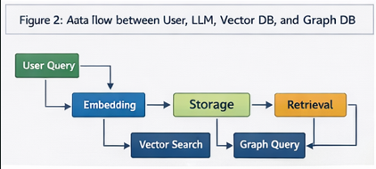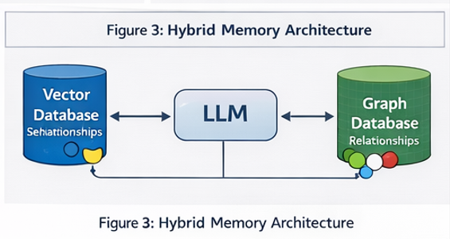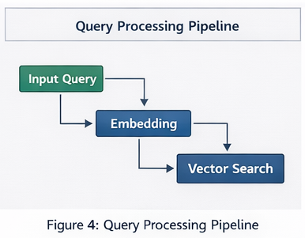
Figure 2 Figure 3 Figure 4

EXPERIMENTS
The primary objective of the experiments is to evaluate the effectiveness of the proposed Enterprise Knowledge Graph with LLMs system in improving contextual understanding, memory retention, and response quality. The evaluation focuses on comparing different memory approaches, including stateless LLMs, vector-based memory, and hybrid memory (vector + graph).
To conduct the experiments, a conversational dataset was created consisting of multiple user queries and corresponding assistant responses. The dataset includes various domains such as technical queries, general knowledge, and task-oriented conversations. Each interaction is stored along with its embedding representation and metadata such as timestamps and session identifiers.
For the experimental setup, the system utilizes embedding generation through an LLM API, which converts textual input into high-dimensional vector representations. These embeddings are stored in a vector database (Qdrant), enabling efficient semantic similarity search. In addition, a graph database (Neo4j) is used to store entities and relationships extracted from the conversations, forming a structured knowledge graph.
During the training and evaluation process, the dataset is divided into multiple sessions simulating real-world conversational scenarios.
The experiments are designed around the following key scenarios:
- Stateless LLM Evaluation:
In this scenario, the LLM generates responses without access to any past interactions. This serves as a baseline to measure the limitations of traditional models.
- Vector-Based Memory Evaluation:
Here, the system retrieves past interactions using semantic similarity search from the vector database. The retrieved context is appended to the query before generating the response.
- Hybrid Memory Evaluation:
In this scenario, both vector and graph memory are utilized. The system retrieves semantically similar interactions from the vector database and related entities/relationships from the graph database. The combined context is then used for response generation.
To measure system performance, the following evaluation metrics are considered:
- Response Relevance: Measures how well the generated response matches the user query
- Contextual Accuracy: Evaluates the system’s ability to incorporate past interactions
- Retrieval Precision: Assesses the accuracy of retrieved memory items
- Response Consistency: Measures coherence across multi-turn conversations
Experimental results are visualized using figures such as semantic similarity clustering, graph-based relationship mapping, and performance comparison charts. These visualizations demonstrate how the system retrieves and utilizes memory effectively.
Additionally, system robustness is tested by intentionally disabling the graph database to evaluate the fallback mechanism. The system successfully continues operation using vector-only memory, confirming its reliability.
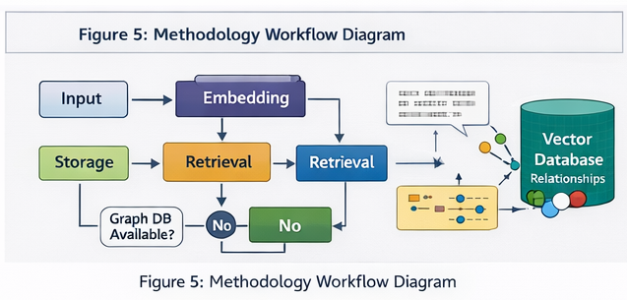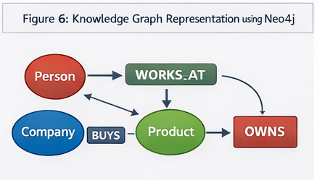
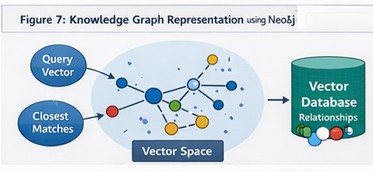

RESULTS
- The Enterprise Knowledge Graph with LLMs system was successfully designed and implemented as a lightweight, command-line interface (CLI) application capable of managing conversational memory in an intelligent and scalable manner. The primary objective of this project was to enhance the capabilities of large language models (LLMs) by introducing persistent memory, enabling the system to retain and utilize past interactions effectively.
- The system demonstrates seamless integration of multiple advanced technologies, including vector-based storage using Qdrant, optional graph-based storage using Neo4j, and LLM-powered response generation through OpenAI API. This hybrid architecture enables both semantic similarity search and relationship-aware knowledge representation.
- During implementation and testing, the application successfully achieved the following outcomes:
Efficient storage of user queries and assistant responses as persistent memory using embeddings
Accurate retrieval of relevant past interactions using semantic similarity search
Improved contextual understanding by incorporating historical conversation data into responses
Support for hybrid memory architecture combining vector and graph-based approaches
Automatic fallback to vector-only memory mode when graph database connectivity failed
Real-time conversational interaction through a simple and user-friendly CLI interface
- The fallback mechanism proved to be highly reliable, ensuring uninterrupted system operation even when the graph database was unavailable or misconfigured. This highlights the robustness of the system design.
- Additionally, the use of vector embeddings allowed the system to understand the semantic meaning of user queries rather than relying on keyword matching, resulting in more accurate and relevant responses. The optional graph-based memory enhanced the system’s ability to capture relationships between entities, further improving knowledge representation.
- Overall, the results confirm that the developed system effectively meets its objectives by providing an enterprise-style intelligent memory layer for LLMs, significantly improving response quality and contextual awareness.

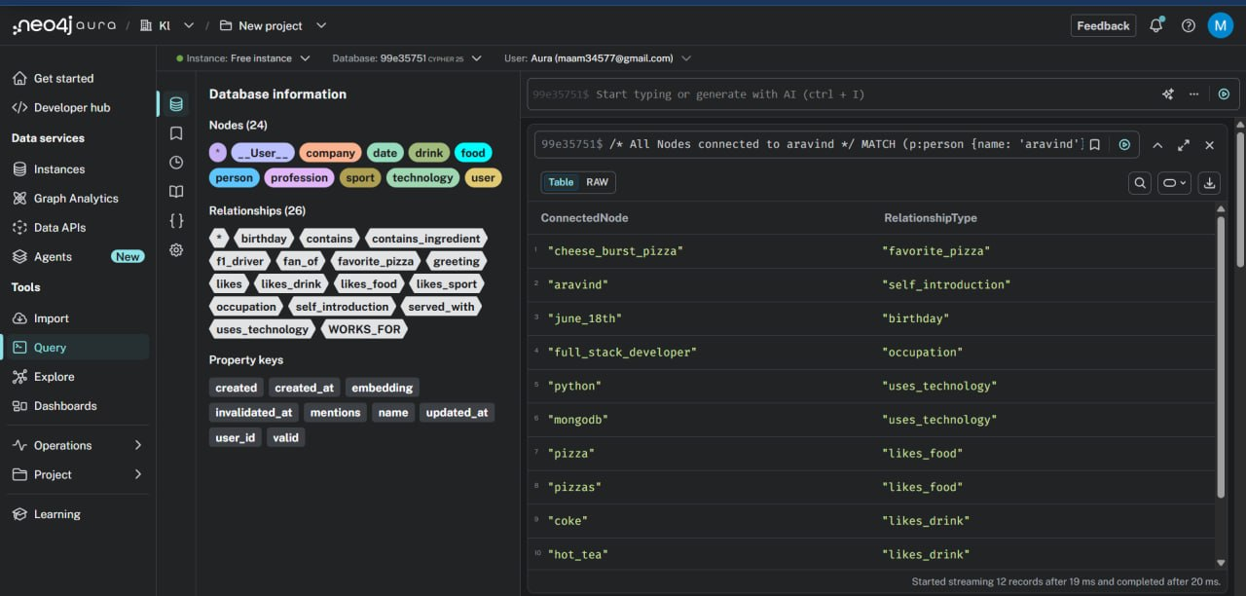
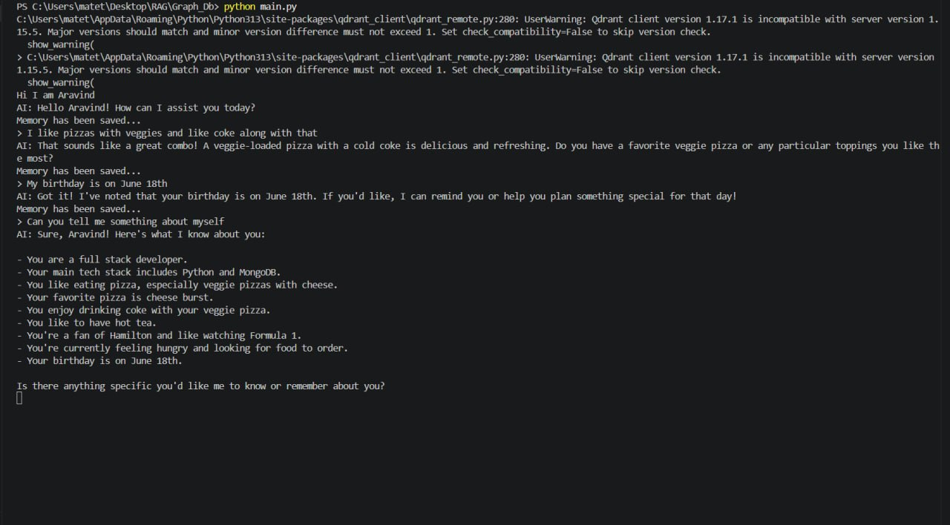

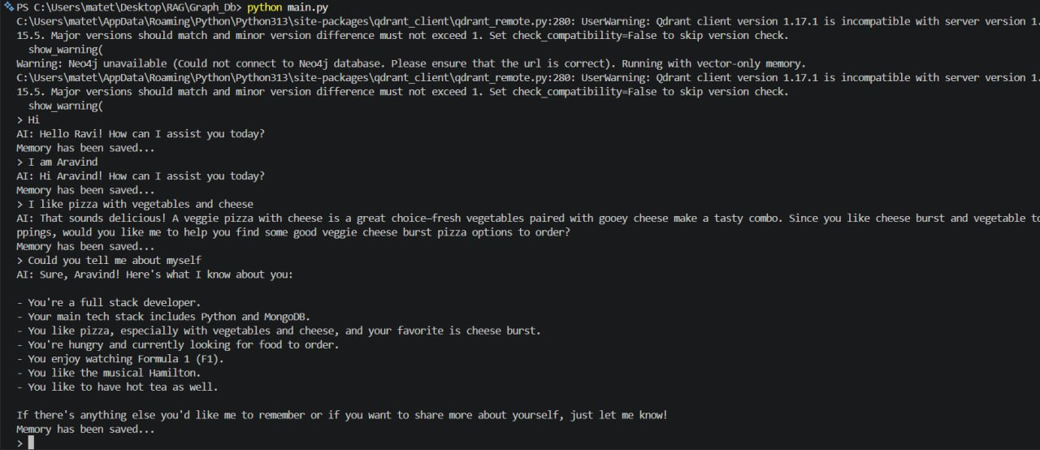

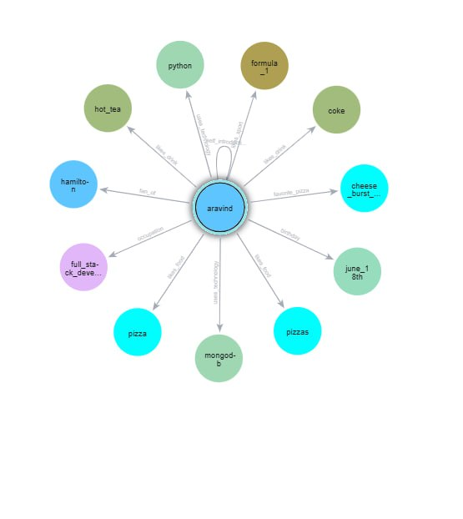

CONCLUSION and FUTURE WORK

The Enterprise Knowledge Graph with LLMs project successfully demonstrates how integrating persistent memory mechanisms with large language models can significantly enhance their performance and usability in real-world applications.
Traditional LLMs are inherently stateless, meaning they do not retain memory of previous interactions unless explicitly provided. This project addresses that limitation by introducing a hybrid memory system that combines vector databases and graph databases. The use of vector storage enables semantic understanding of user inputs, while graph storage allows the system to capture relationships and structured knowledge.
This dual-memory approach makes the system highly suitable for enterprise-level applications such as intelligent virtual assistants, customer support automation, knowledge management systems, and decision support tools. The ability to recall past interactions and use them to generate more relevant responses improves both user experience and system efficiency.
The modular architecture of the system ensures flexibility and adaptability. It can operate in a vector-only mode when graph memory is unavailable, making it resilient in different deployment environments. This design also supports scalability, allowing future extensions and integrations.
Despite its successful implementation, the project has certain limitations:
- User identification is currently hardcoded instead of being dynamically managed
- Absence of authentication and role-based access control mechanisms
- Limited to a CLI interface, lacking a graphical or web-based user interface
- Minimal implementation of logging, monitoring, and error handling
- No deployment on cloud infrastructure for real-world scalability
To further enhance the system, the following improvements are recommended:
- Development of a web-based or mobile interface for improved usability
- Implementation of multi-user support with secure authentication mechanisms
- Integration of advanced security features such as encryption and access control
- Enhancement of graph-based reasoning and relationship extraction capabilities
- Deployment using cloud platforms for scalability and high availability
- Addition of monitoring tools and logging frameworks for production readiness
In conclusion, this project provides a strong and scalable foundation for building next-generation AI systems that leverage LLMs with persistent and intelligent memory. With further enhancements, it has the potential to evolve into a full-fledged enterprise-grade solution.

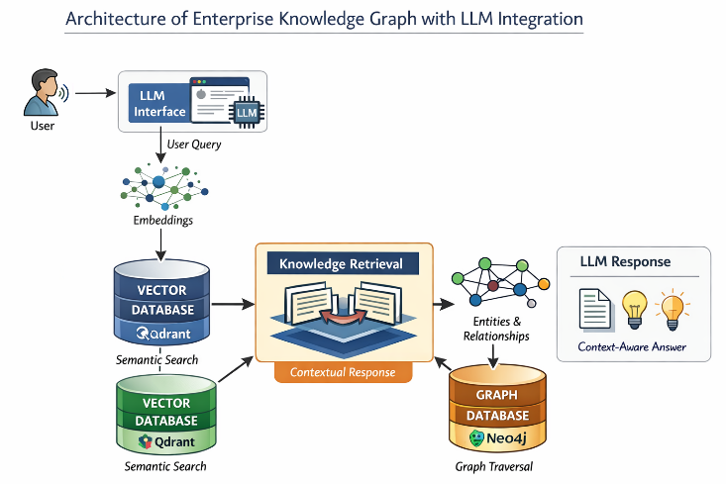

References

- OpenAI, "OpenAI API Documentation," Available: https://platform.openai.com/docs
- Qdrant Team, "Qdrant Documentation," Available: https://qdrant.tech/documentation/
- Neo4j, "Neo4j Documentation," Available: https://neo4j.com/docs/
- Mem0, "Mem0 Documentation," Available: https://docs.mem0.ai/
- Docker Inc., "Docker Documentation," Available: https://docs.docker.com/
- Python Software Foundation, "Python 3 Documentation," Available: https://docs.python.org/3/
- LangChain, "LangChain Documentation," Available: https://python.langchain.com/docs/
- Hugging Face, "Transformers Documentation," Available: https://huggingface.co/docs/transformers
- Wikipedia Contributors, "Knowledge Graph," Available: https://en.wikipedia.org/wiki/Knowledge_graph
- Wikipedia Contributors, "Word Embedding," Available: https://en.wikipedia.org/wiki/Word_embedding

